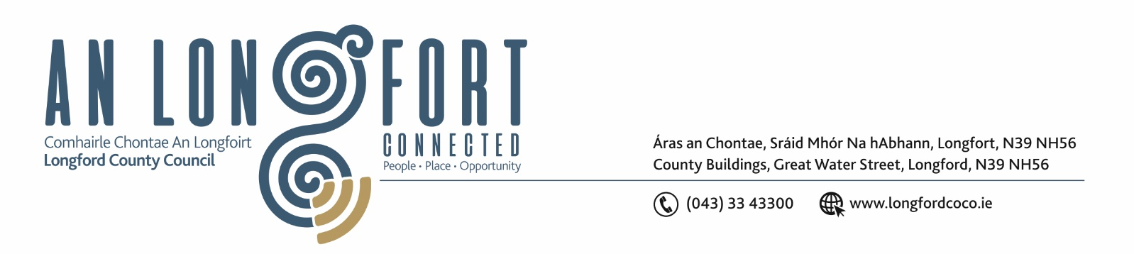

Please note meeting will commence at 3.30 p.m.
Paddy Matthews, Head of Operations, Ireland’s Hidden Heartlands will attend
meeting at 3.30 p.m.

4u Mean Fomhair 2018.

Chuig: Gach Ball don Chomhairle.

A Chomhairleoir,

Iarrtar ort bheith i láthair ag Cruinniú Míosuil Chomhairle Chontae Longfoirt a tionólfar i Seomra na Comhairle, Aras an Chontae, Longfoirt ar an Chéadaoin, 10th Mean Fomhair 2018 ag 3.30 p.m chun gnó a dhéanamh d’réir an Chláir thíos.

You are requested to attend the Monthly Meeting of Longford County Council to be held in the Council Chamber, Aras an Chontae, Great Water Street, Longford, on Wednesday, 10th October 2018 at
3.30 p.m. to transact business, as set out on the Agenda hereunder.

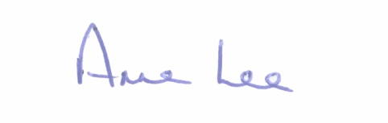
Mise le meas,

_______________
Anne Lee,
Meetings Administrator.

C L A R

Prayer before Meeting.

- Confirmation of Minutes of the following Meetings of Longford County Council -

- Monthly Meeting held on the 12th September 2018.
- Special Meeting held on the 18th September 2018.
- Adjourned Monthly Meeting held on the 18th September 2018.
- copies enclosed.

2. Matters arising from Minutes.

3. To note Chief Executive Orders. (Summary herewith)

4. To note Monthly Management Report - to follow.

5. To note adopted Minutes of Corporate Policy Group Meeting held on
11th July 2018 - (copy enclosed).

6. Finance & Information Systems.
(a) To note Public Liability Claims received during September 2018 – report enclosed.

(b) Consideration of the Local Government Audit Service Statutory Audit Report for the year ended 31st December 2017 – enclosed.

(c) Consideration of Overdraft Accommodation of €5.5m for year ending 31st December 2019.

(d) To fix dates for the following Meetings -
- Municipal District Meetings to consider draft Budgetary Plan for 2019.
- Longford County Council Finance Committee meeting to consider 2019 Budget.
- Longford County Council Statutory meeting to consider 2019 Budget.

(e) Notices of Motions submitted by Councillors, as listed hereunder –

Councillor Micheal Carrigy

“I call on the Minister for State, Michael Darcy, T.D., to introduce legislation compelling Insurance companies to report fraudulent claims to the Gardai. Any person making a fraudulent claim should be prosecuted and fined.”
Councillor Gerry Warnock
“I am calling for the immediate implementation of a Digital Contact Management System (ideally in App Format) to formally deal with Councillors Representations or Queries. The system should include provision to escalate the Representation/Query to Senior Management Level if no response is issued within a defined and reasonable timeline.”

7. Housing, Infrastructure, Environment & Emergency Services.

- Consideration of Draft Billing Policy for Fire Service Charges – enclosed.

- Consideration of Draft Section 26 – 5 year Operational Fire Service Plan - enclosed.
- To note adopted minutes of Housing SPC meeting held on Tuesday 1st May 2018 – enclosed.

- To note adopted minutes of Infrastructure SPC meeting held on Wednesday 6th June 2018 – enclosed.

(e) Recommendations from Infrastructural and Environmental Strategic Policy Committee -

(i) “That legislation regarding Litter Fines be reviewed”.
(ii) “That signage regarding dog fouling be erected in all Council owned parks, walkways and playgrounds”

(iii) “That funding be sought for the provision of a new Fire Station in Ballymahon. “

(f) Notices of Motions submitted by Councillors, as listed hereunder –

Councillor Paul Ross

“I call on Longford County Council to add sites or holdings which contain Japanese Knotweed, and are not being treated by the property owner in conjunction with Longford County Council, to the Derelict Sites register in County Longford.”

Councillor Gerry Warnock

“I am calling on Longford County Council Housing Department to expand the usability of the Choice Based Letting Scheme. It is many months now since the very successful pilot was ran and yet the scheme remains dormant. CBL is an efficient and transparent tool to deal with the allocation of Housing Stock and should form a central role in delivering this service in a consistent and transparent manner in accordance with already adopted policy”

“I am calling on Longford County Council Housing Department to give the Elected Members a breakdown of Households Approved for Social Housing Support together with Stock available at this point in time. Information should include:
- The Type of Household (Single applicants, Single Parent Families, Two Parent Families, Special Needs)
- The Demand per Municipal District for each Type of Household (which can be determined by first choice on Application)
- A breakdown of housing units available in each Municipal District (including Voids)
This exercise will be useful to the Elected Members in terms of making more informed decisions pertaining to Housing Policy. I have asked on numerous occasions at SPC level for this information to be made available to the Elected Members.”

Councillor Joe Flaherty.
“Call on Longford County Council to facilitate the establishment of a county-wide Anti Litter Task Force that will include reps from local Tidy Towns, business and community groups with a vested interest in tackling the issue. The Forum will dovetail with the Council's own Environmental team and through the implementation of county wide best practice and the sharing of idea and resources, enable the forum to set a target of being the first county in Ireland to achieve 'litter free' status.”
Councillor Michael Carrigy.

“I call on Longford County Council to develop a plan to make Longford a Disability Accessible Town. I propose that a person representing the views of people with disabilities would be appointed to the Infrastructure and Environment SPC.”

8. Economic and Community Development, Planning, Human Resources & Corporate Services, Cultural & Recreational Services.

- To note Planning Applications received since July meeting of the Council.

- Preparation of Register of Electors.

- To note adopted minutes of Economic SPC meeting held on Monday 28th May 2018 – enclosed.

- Notices of Motions submitted by Councillors, as listed hereunder –

Councillor Mae Sexton – deferred from September meeting.

“That Longford County Council takes in charge Mastertech Business Park on the Royal Canal Avenue on Athlone Road”.

Councillor Colm Murray.

"I propose that Longford County Council host a civic reception in honour of Bishop Richard B. Higgins, native of Abbeyderg, Kenagh, Co. Longford to mark the 50th anniversary of his ordination in Rome in March 1968. Bishop Higgins has risen through the ranks of the Catholic Church in the USA to become Auxiliary Bishop at the Archdiocese of the Military Services"
Councillor Michael Carrigy.
"That Longford County Council set up a Bursary Scheme to help young sports people in the County further develop their skills and help with college fees etc."

9. General

- Notices of Motions submitted by Councillors, as listed hereunder –

Councillor Paul Ross.

“I call on Longford County Council to write to the Minister for Justice and the Garda Commissioner to seek funding for the construction of a new Garda Station in Edgeworthstown.”

Councillors Mae Sexton, Peggy Nolan, Micheal Carrigy, Joe Flaherty & Gerry Warnock:
“We are calling on Longford County Council to write to the Minister for Health, Simon Harris, and the Health Products Regulatory Authority (HPRA) calling on them to vigorously enforce the provisions of the Medicinal Products (Control of Placing on the Market) Regulations 2007, relating to the prohibition of Miracle Mineral Solution (MMS) and other such unregulated medical quackery currently being peddled largely by unscrupulous, financially motivated entities as a cure for autism.

The victims of these quackeries are mainly children who have suffered both physically and psychologically as a result. This is inhumane and in our view severe abuse of vulnerable children. We are requesting that this motion be forwarded to all other Local Authorities to add weight to this issue.”

- Correspondence – circulated.

- Letter dated 11th September 2018 received from the Office of the Minister for Health regarding CervicalCheck.
- Letter dated 17th September 2018 received from the Office of the Minister for Housing regarding the current Tenant Purchase Scheme.

10. Votes of sympathy.

11. Training -
Consideration of Report from Corporate Policy Group.



